# **Add Account in outlook App**

1. Open outlook APP> Click on File > Account Setting > Click on Add/remove account

1. Select New

1. Add account credentials click on next and finish.

# Export and take a backup of outlook mails of ProjectObjects.com Domain

1. Open outlook APP > Select **File** > **Open & Export** > **Import/Export**.

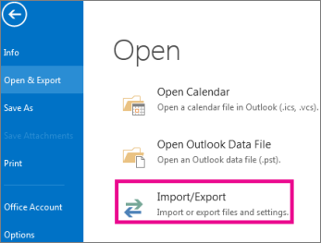

1. Select **Export to a file**, and then select **Next**.

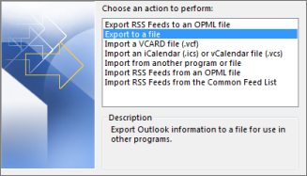

1. Select **Outlook Data File (.pst)** and select **Next**.

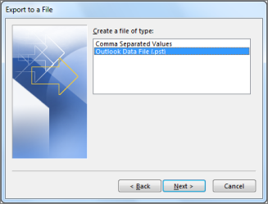

1. Select the mail folder you want to back up (here select mail ID of projectobjects.com) and select **Next**.

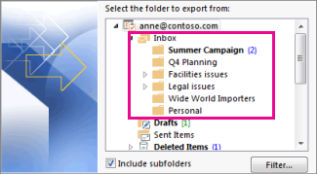

1. Choose a location and name for your backup file, and then select **Finish**.

The location could be left as it is backup file will be saved in documents folder with name outlook files.

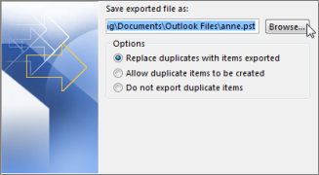

1. If you want to ensure no one has access to your files, enter and confirm a password, or can leave blank and then select **OK**.

# **Import and save all the mails of the projectobjects.com domain to the ID of the uppwise.com domain**

1. Open Outlook APP > Click on ID of uppwise.com domain

1. Select **File** > **Open & Export** > **Import/Export**



1. Select **Import from another program or file**, and then select **Next**.

1. Select **Outlook Data File (.pst)** and select **Next**.



1. Browse the backup outlook file of projectobjects.com domain ID which was taken earlier



1. Check on Import Item to the same folder and select uppwise.com > **FINISH**

